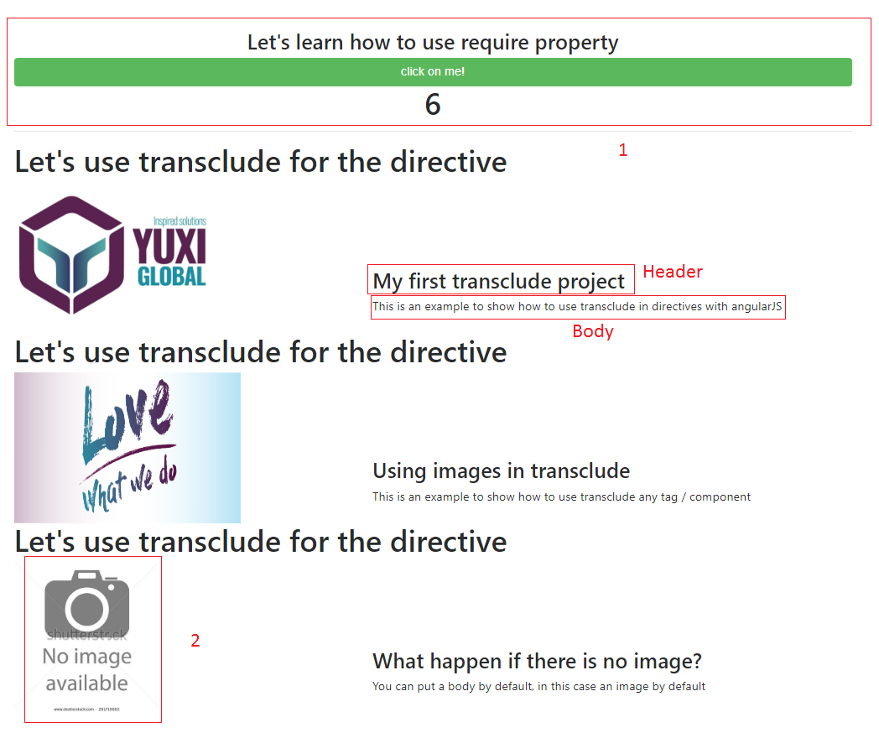

Instructions:

* Create two directives for the require implementation, the first one should have only the counter, then call the child directive and pass a label using transclude, in the child directive should have the button (Remember to use require to the parent directive, so we can execute a function from the parent) which executes the addCounter function from the parent - 1
* Create a new directive for the transclude exercise, this directive should receive the image (Not mandatory) and the body using transclude, pass the header by bindToController.
* In the third time when you call the directive don’t pass the image, it should show an image by default. - 2